Treating Customers Fairly

Church of Scotland Insurance Company Limited

Policy Document


Version Control
Version | Date | Author | Change Description
1.0 | 28/02/11 | KR | Redraft of current wordings.
2.0 | 09/03/11 | KR | Changes to some drafting, amendment to performance indicator report.
3.0 | 01/06/11 | KR | Update to clarify roles and responsibilities, make the MI report more transparent through the labelling of specific measures, and update to the 6 TCF outcome areas.
4.0 | 28/6/12 | KR | Annual review completed and amendments made to a number of sections to bring them up to date
5.0 | 16/4/13. | KR | Annual review and update

The Church of Scotland Insurance Company Ltd

TCF Policy Statement

The Church of Scotland Insurance Company Ltd (‘The Company’) puts TCF at the cornerstone of its activities to ensure the fair treatment of our customers is taken very seriously. It focuses on achieving the six consumer outcomes as outlined. The Company’s management and staff are developing a culture which is open to change such that it will continuously challenge itself to improve its products, services, and culture. Building on the significant work undertaken in recent years the following is in place.

TCF Roles and Responsibilities
The Board
The Board takes responsibility for ensuring that the senior management and staff of the company are focused upon delivering fair outcomes for its customers. It does so by working through its sub committees to challenge itself and the operational team by regular review of the customer focused management information delivered at Board Meetings.

Senior Management

The senior management team have responsibility for displaying leadership within the business for the fair treatment of customers. Managing training and any refresher training that is needed in this area receives a high priority. Control over the delivery of TCF is exercised through, observation, discussion, regular quality reviews, and the monitoring of outcomes through the capture of appropriate management information which is reported upwards to the Board in a Monthly Performance Indicator and Quarterly Report.

Staff

Every member of the team has a role profile which is TCF focused, and they are challenged to maintain a customer approach which delivers fair outcomes through regular discussions, review and training. All members of the team have behavioural and task objectives designed to support the ethos of TCF.

Mission statement

A mission statement was introduced in 2008 with treating customers fairly at its core:

“A centre of professional excellence; providing underwriting/broking expertise, value products and associated advice to Congregations of the Church of Scotland and other denominations at an affordable price; to treat customers fairly at all times; to be the proactive and recognised source of general insurance advice to the Church of Scotland, General Trustees, Presbyteries and Congregations; and to provide a consistent level of underwriting performance and profitability enabling the business to support continued Gift Aid contributions.”

The Company ‘’Way’’ - Beliefs/Values

In 2011 to enhance the TCF ethos within the Company’s culture and working practices. The six outcomes were mapped to the company’s team beliefs and values concerning how we deal with our customers and a service level undertaking was introduced to support this (see next page).

The Company values mapped to TCF outcomes
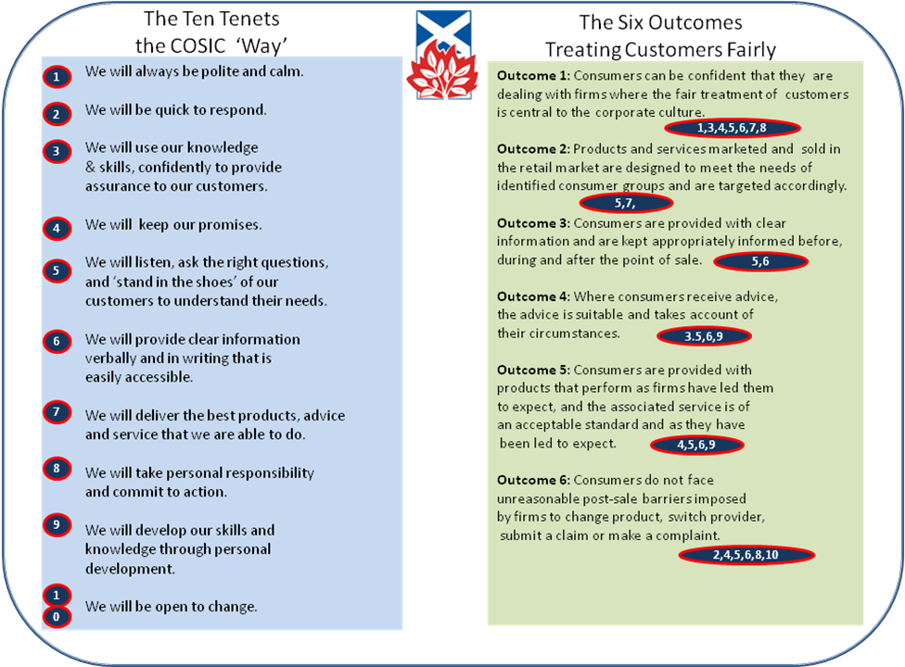
The Company Service Levels
Category | Customer Service | Target
Telephones | Answer the telephone | Within 2 rings
Answer phone | Always put on when the office is closed or the team is unavailable | Ring the message leaver back within 24 hours
General Correspondence | Deal with – correspondence, e-mails, mid term alterations, and quotations. | Within 3 working days. If not possible acknowledge and advise completion date. Quotations by deadline.
Renewals | Issue Scheme, Non Scheme, Household renewals | At least 25 days prior to renewal
Claims | Issue claim forms | 1^{sty} Class post same day notification
 | Fire Claims cheques | Issued within 2 days of receiving final report ( and approval from THE COMPANY Board if required)
Complaints | Deal with complaints fairly and quickly | a) Initially by close of next working day, if this is not possible then
 | If satisfied complaint should be more properly the responsibility of another firm the Chief Exec may forward promptly to them | b) Acknowledge within 5 working days  c)Full resolution within 4 weeks  ( with an update after 10 working days)
This Policy document now considers in turn each of the TCF outcomes and describes the company’s processes and actions to ensure fair outcomes are delivered;

Outcome 1: “Consumers can be confident that they are dealing with firms where the fair treatment of customers is central to the corporate culture.”

The Board and the operational team take its high level responsibilities in support of consumer protection very seriously.

At an operational level the following is in place:

- Feedback from customers, Presbytery, and Congregational visits is considered to establish what can be improved and taking action when needed.
- Periodic review of all customer facing documentation from a TCF perspective.
- Monthly staff team meeting to ensure everyone is up to date with what is happening within the Company.
- Weekly staff huddle to share information and prioritise issues.
- Annual appraisal and clear business objective setting.
- Creation and implementation of Broker Assess Personal Development Plans; utilisation of this and other resources to maintain and monitor competence.
- The Company’s Compliance Framework.
- BIBA Compliance Manual.

In addition to the above the Board and the Insurance Committee meet quarterly and discuss and review operational and strategic insurance related matters. As part of this review there is a regular focus on the delivery of service to our customers.

The following high level documents and activities also form part of the process to ensure the Company’s delivery of fair outcomes for its customers, and allows the Board to exercise oversight and control:

- Monthly Performance Indicator Report and Quarterly Report; including specific TCF measures.
- The Terms of Reference for all Committees of the Board and their operation.
- Board challenge through the operation of its sub-committees and at regular Board meetings.
- Formal Risk Assessment process and Risks Register.
- Conflicts of Interest Policy.
- Knowledge and awareness of the Board of TCF issues.
Outcome 2: “Products and services marketed and sold in the retail market are designed to meet the needs of identified consumer groups and are targeted accordingly.”

The products and services marketed by the Company fall into several areas, including acting as both insurer and intermediary [changing in 2013 – intermediary only by year end] for its customers and the provision of administrative and claims support for the following arrangements, its main focus is the provision of services to the ecclesiastical market and its arrangements have been developed with this in mind:

- For eligible churches, the Company offers a single specialist Scheme insurance product.
- The fire insurance on the scheme is underwritten by the Company [this is ceasing in 2013], with the balance of perils cover being provided by one or more insurers.
- For other classes of insurance and non Scheme church insurance, the Company selects products from a limited range of insurers, the names of which are available on request.
- For new household insurance, the Company offers the scheme products of one insurer.

In order to ensure our products meet the needs of our customers a number of activities have recently been undertaken:

- Analysis of competitor product offerings in the church market has been undertaken, and extensions to the Scheme product obtained.
- In January 2011 and 2012 the balance of perils wording under the Scheme has been substantially extended, and is benchmarked against the principal competitor products.
- In January 2013 a new package policy wording was introduced under the Scheme – with significantly extended covers at a lower unit cost. Plus a simplified and more easily understood Policy wording and Summary.
- Greater interaction with Church Scheme customers to advise them of the benefits of the new wordings and provide them with assistance in shaping cover to their needs.
- The Household wording and servicing arrangements have been reviewed and updated.
- Claims processes and suppliers have been reviewed, and a Claim supplier changed in 2012.
- Consideration of risks and impacts to customers form part of the Company’s risk register.

Outcome 3: “Consumers are provided with clear information and are kept appropriately informed before, during, and after the point of sale.”
To deliver this outcome the Company undertakes the following:

- For all new Church scheme business an extensive questionnaire is completed to ensure customer demands and needs are properly established ref.1/001.
- A peer review of every non scheme business sales is undertaken using a checklist ref. 5/006.
- All policyholders also receive a policy schedule outlining the sections of the Scheme policy that apply in their circumstances together with all sums insured, and any important limits and endorsements applying..
- Files, in hard copy, are retained. These contain full records of all risks insured with transactional details.
- A Policy Summary which is regularly updated and available on the web site is also provided. A new hard copy Policy Summary is being issued with all Scheme renewals in 2013.
- A web site was developed and launched in 2009, it provides easy access to relevant policy wordings, FAQs, and other services, and was substantially improved in successive years thereafter. The site was completely re built in 2013.
- A comprehensive repository of all the Company’s customer facing documentation has been established, and this is subject to ongoing review to ensure it is jargon free and easily understood. It was substantially updated in April 2013.

Outcome 4: “Where consumers receive advice, the advice is suitable and takes account of their circumstances.”

The following is undertaken to ensure this outcome is achieved within the Company:

- Staff are encouraged to further their professional qualifications and maintain up to date knowledge and skills.
- As part of the annual appraisal process, 121 meetings, and team meetings issues relating to staff understanding and knowledge are reviewed.
- Each member of staff is encouraged to have a Broker Assess Personal Development Plan and this is subject to regular review.
- A peer review of every non scheme business sales is undertaken using the checklists ref: 5/006, 5/007, and 5/008.
- The staff have been given guidance on the difference between advised and non advised sales.
- Quality control reviews of files including a review of TCF is part of the Company’s review and monitoring procedures.

Outcome 5: “Consumers are provided with products that perform as firms have led them to expect, and the associated service is both of an acceptable standard and also as they have been led to expect.”

This is governed by a number of factors:

- By far the greatest majority of business underwritten and arranged by the Company is in respect of insurance cover for the properties owned by the General Trustees who, on behalf of the Church of Scotland, are the owners of the Company. Their input to the proposition balancing cover and premiums is sought regularly.
- A mission statement has been developed to provide a focus on delivering a “A centre of professional excellence; providing underwriting/broking expertise, value products and associated advice to Congregations of the Church of Scotland and other denominations at an affordable price; to treat customers fairly at all times’’
- The Scheme product was substantially enhanced in 2013, and the Company team keep their products and services under review by drawing on their knowledge of the market.
- The Company also takes account of claims that are not paid and seeks to address any cover issues where possible. The extent of cover provided is kept under review and were appropriate discussions are opened with providers with a view to refining or broadening the scheme arrangements. This approach also extends to claims processes and claims handling, and the introduction and review of service level undertakings is a key element.
- Policy cover under the Scheme as part of this review was substantially extended in 2013.
- Key strands in the Company’s values are ‘’understanding our customers needs’’, ‘’keeping our promises’’ and ‘’delivering the best products and services that we are able to do’’.

Outcome 6: “Consumers do not face unreasonable post-sale barriers imposed by firms to change product, switch provider, submit a claim or make a complaint.”

The Company holds a number of values and beliefs at the heart of its interaction with its customers which it is believed will ensure that they do not face unreasonable, post sales barriers to change products or switch a provider.
- The Company provides customers with clear information during the claims processes.
- A clear explanation is offered for the rejection or partial settlement of a claim and we work closely with suppliers to ensure our customers are kept properly informed through this difficult process.
- The Company handle claims fairly and promptly with due regard to all of the circumstances.
- Claims are subject to quality review and we seek to improve our processes as a result.
- The Company considers and apply relevant guidance from the financial regulator(s) & the FOS.
- Claims are paid promptly once liability has been accepted and we work with our suppliers to ensure they do likewise through monitoring of the progress of claims and the introduction of SLAs.
- Complaints handling processes have been reviewed and customer feedback is a regular item on team meetings.

